Project w 10

\*\*Next call 10/15 @ 2PM\*\*

9-15-14: Call held and Mansour said he should be on track for Task 2 deliverable on 10/1.

\*\*Next Call 9/15 @ 2pm\*\*

8-20-14: Call cancelled by TA and PI. Nothing to really disuss at this point in the project.

\*\*1st Monthly Call -August 18 @ 2pm\*\*\*Call moved to 8/20 @ 10am\*\*\*

7-11-14: Held KOM.

7-9-14: Emailed kick off meeting agenda.

7-1-14: Confirmed that KOM will be 7/11 @ 2pm at the Lab.

6-27-14: Rescheduled Kick-off Meeting to 7/11/14 @ 2pm in person at the Lab.

6-23-14: Kick-off Meeting Agenda completed and saved.

6-17-14: NTP Packet sent to Petruca. (Email saved) NTP 7/1/14. Kick-off Meeting 7/11/14 @ 8:30am.

NTP: 7/1/2014

6-16-14: PO approved.

Increased cost ok`d by LT and MB

5-27-14: Shelly W created shopping cart - POs can`t be processed until 7/1/14.

5-20-14: Shelley S created WBS element

4-9-14: Use 141597-216 as vendor number

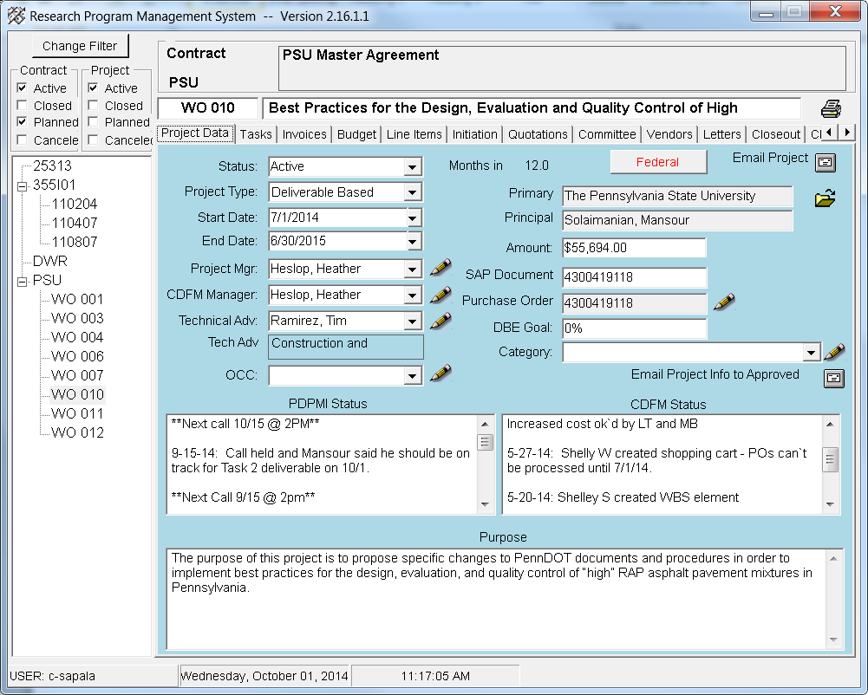

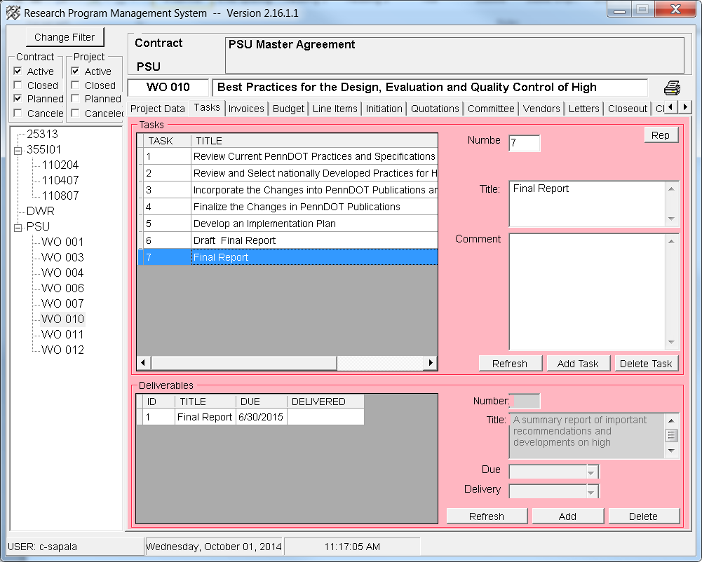

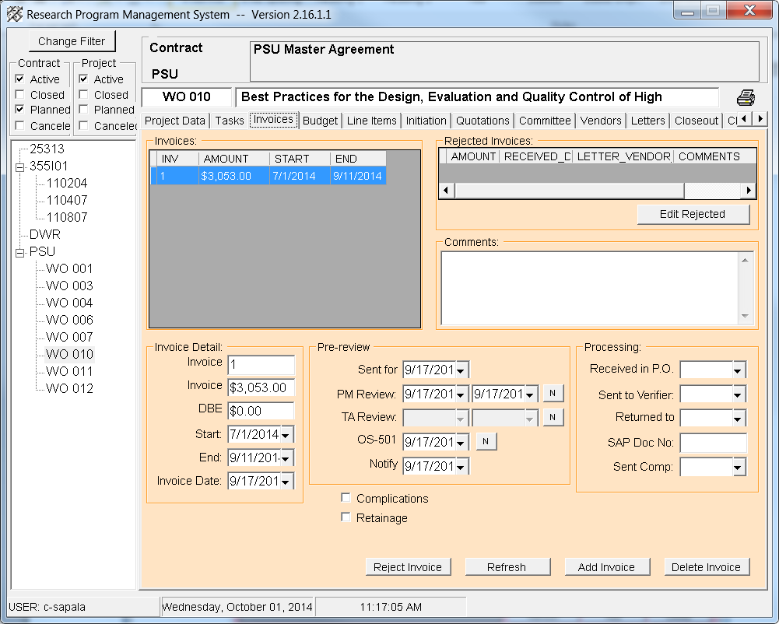

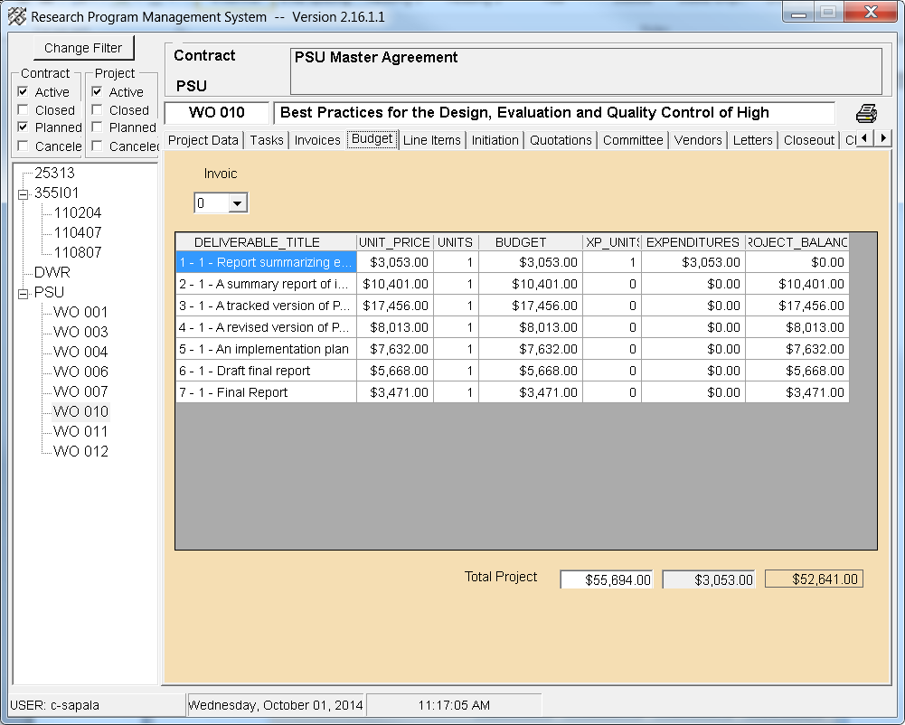

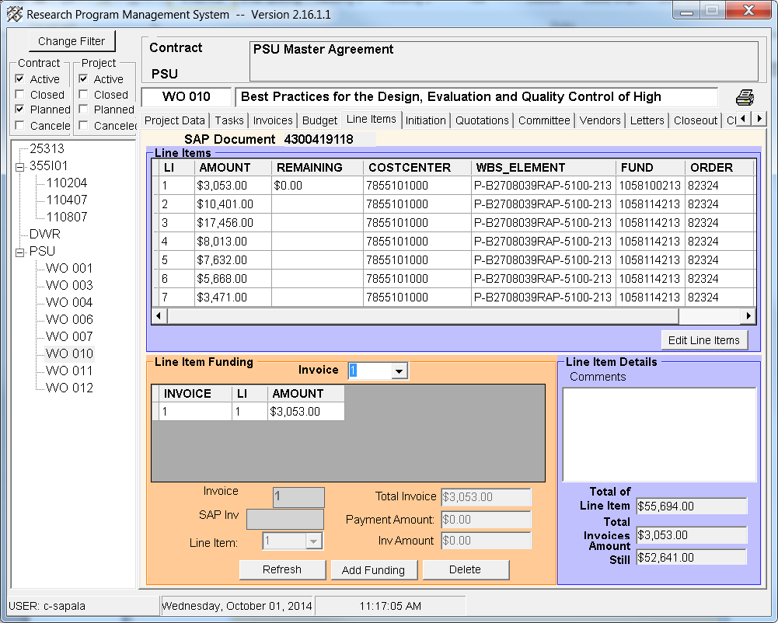

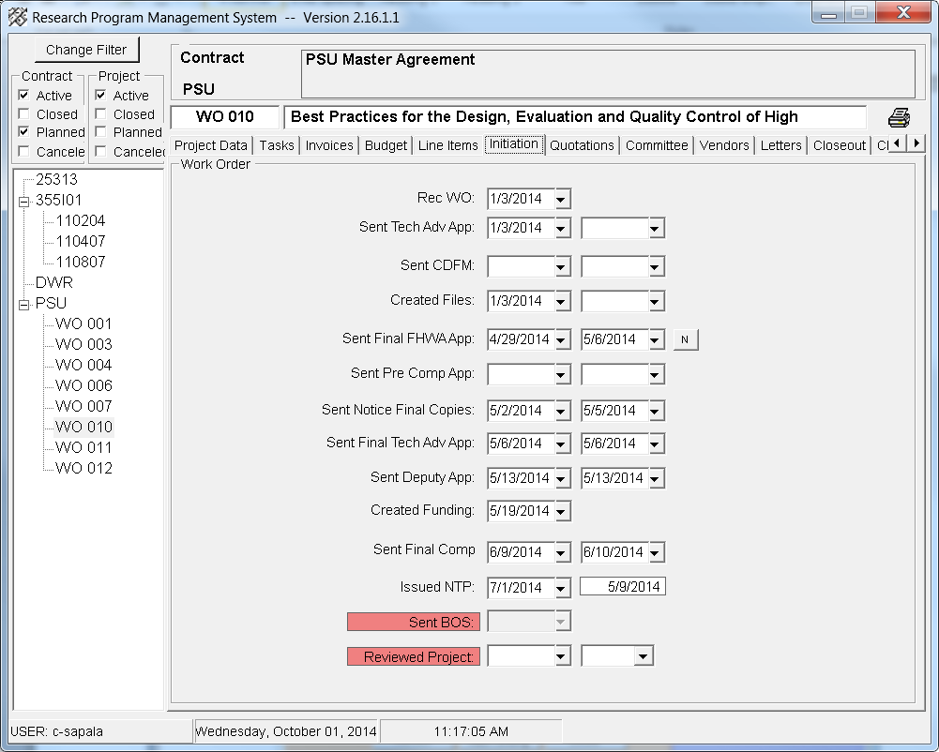

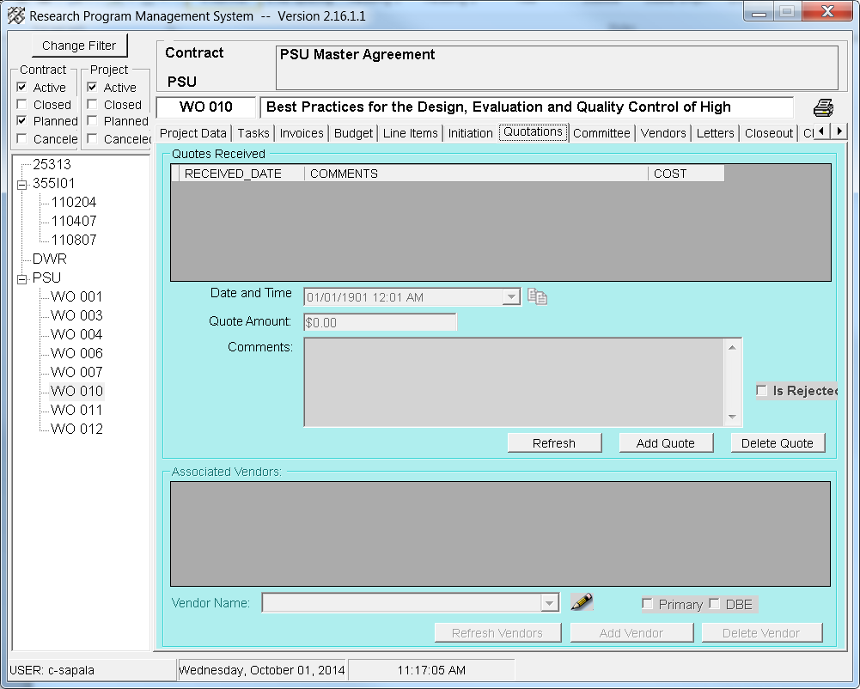

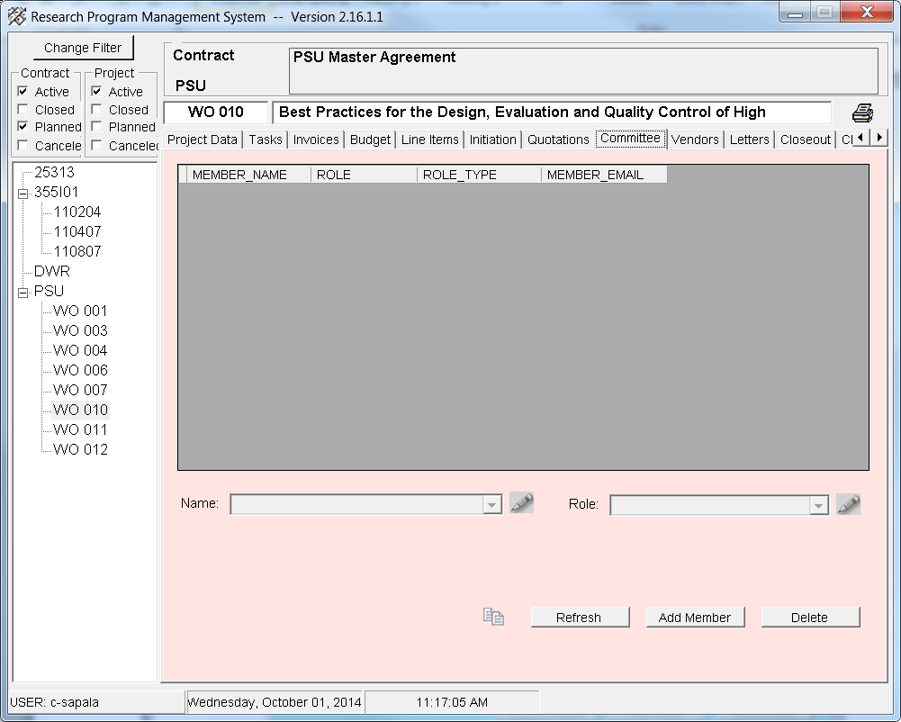

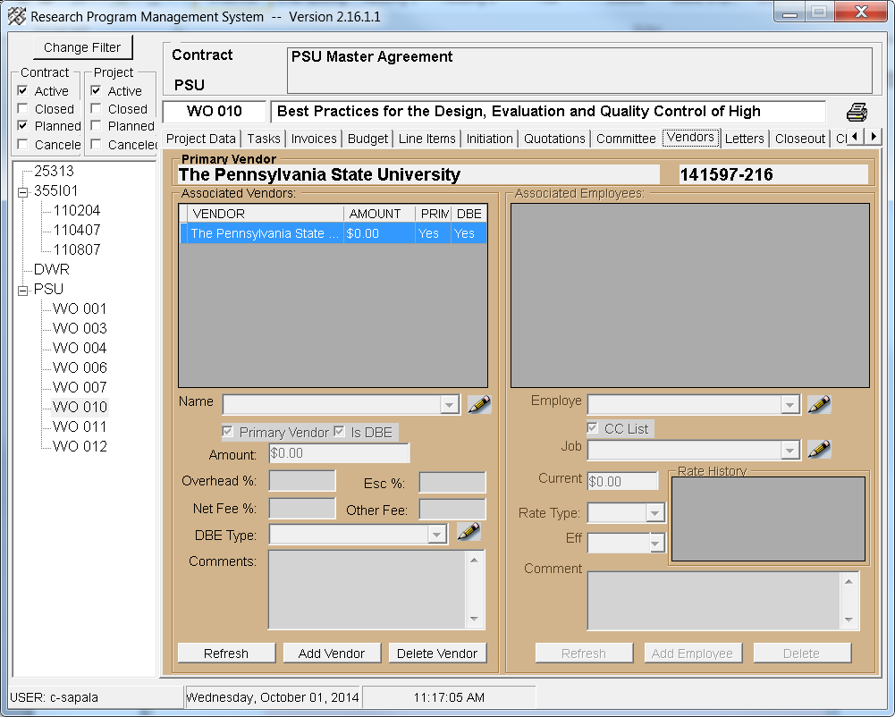

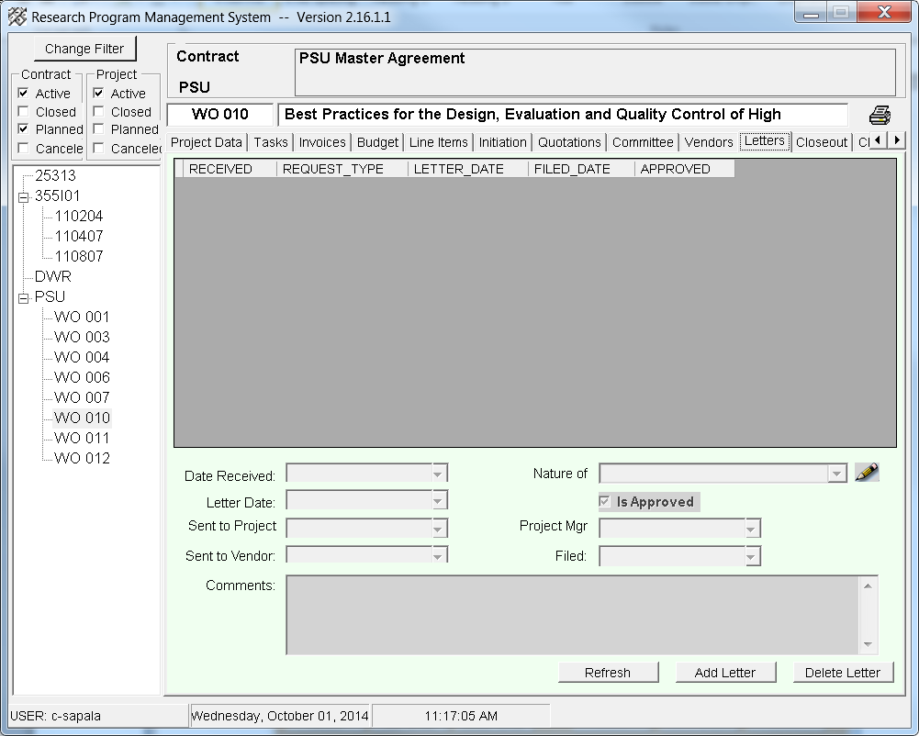

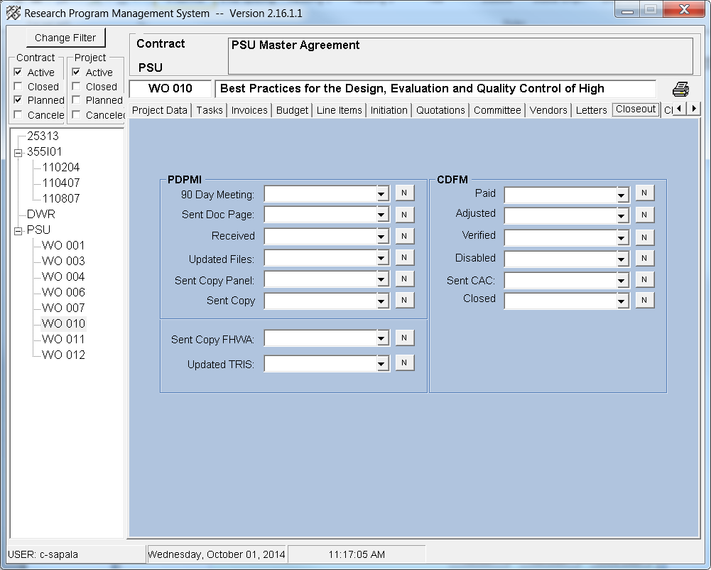

Task

Task 1 Review Current PennDOT Practices and Specifications of RAP Usage

9-11-14: Tim approved Task 1 deliverable. Email sent to PSU approval to invoice.

8-26-14: Mansour submitted Task 1 deliverable via email. Sent to Tim for review and approval.

Task 2: Review and Select nationally Developed Practices for High Percentage RAP

10-1-14: Mansour submitted Task 2. Forwarded to Tim for his review and approval by 10-15.

Task 3:Incorporate the Changes into PennDOT Publications and Minimum QC Requirements

Task 4: Finalize the Changes in PennDOT Publications

Task5: Develop an Implementation Plan

Task6: Draft Final Report

Task7: Final Report